
Story

Date | 24 September 2024
Team ID | PNT2022TMIDxxxxxx
Project Name | Electric Vehicle Market Performance & Insights
Maximum Marks | 5 Marks

By using stories in Tableau, you can effectively communicate complex data in a way that is both interactive and engaging, making it easier for the audience to follow along and understand the insights. It’s a tool for data storytelling, allowing you to present insights in a cohesive, engaging way that takes viewers through a logical progression of findings or analyses.
In Tableau, Story is a feature that allows you to create a sequence of dashboards, visualizations, and text to present data insights in a cohesive and narrative-driven way. It's like a slideshow within Tableau that guides the audience through a series of data points, helping them understand key insights, trends, or outcomes of your analysis.

Screenshot of Story:
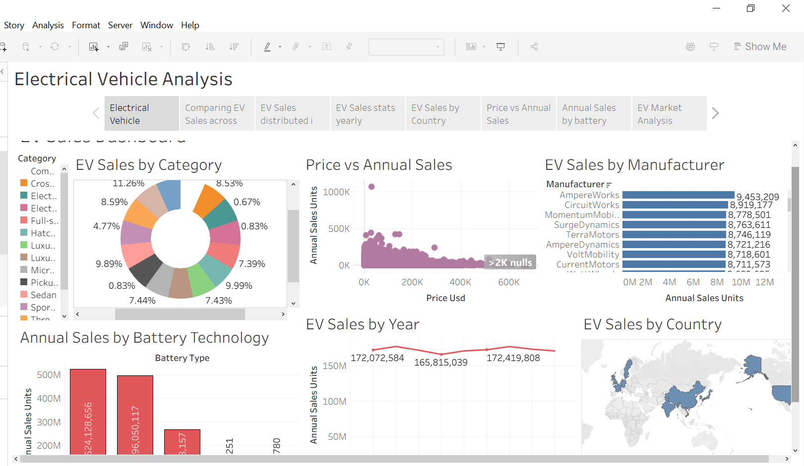

Observations
- Manufacturer Performance: Compares sales across different EV manufacturers.
- Category Analysis: Highlights the leading EV category based on sales.
- Sales Trends: Shows yearly changes in EV sales.
- Battery Technology: Compares annual sales across different battery technologies.
- Manufacturing Distribution: Highlights EV manufacturing across countries.
- Price vs Annual Sales: Explores the relationship between vehicle prices and annual sales.
- Manufacturer Distribution: Uses a treemap to show EV sales distribution among manufacturers.

Activity 2:
https://public.tableau.com/app/profile/navya.rai3458/viz/EVSalesProjectTableau/Story1?publish=yes

